Excretion of Drugs

- Excretion is defined as the process whereby drugs and/or their metabolites are irreversibly transferred from internal to external environment.
- Excretion of unchanged or intact drug is important in the termination of its pharmacological action.
- The principal organs of excretion are kidneys. Excretion of drug by kidneys is called as renal excretion. Excretion by organs other than kidneys such as lungs, biliary system, intestine, salivary glands and sweat glands is known as nonrenal excretion.

RENAL EXCRETION OF DRUGS
- Almost all drugs and their metabolites are excreted by the kidneys to some extent or the other.
- Some drugs such as gentamicin are exclusively eliminated by renal route only.
- Agents that are excreted in urine are –
- Water-soluble.
- Non-volatile.
- Small in molecular size (less than 500 Daltons).
- The ones that are metabolised slowly.

- The basic functional unit of kidney involved in excretion is the nephron. Each kidney comprises of one million nephrons.
- Each nephron is made up of the glomerulus, the proximal tubule, the loop of Henle, the distal tubule and the collecting tubule.

The principal processes that determine the urinary excretion of a drug are –
- Glomerular filtration.
- Active tubular secretion.
- Active or passive tubular reabsorption.
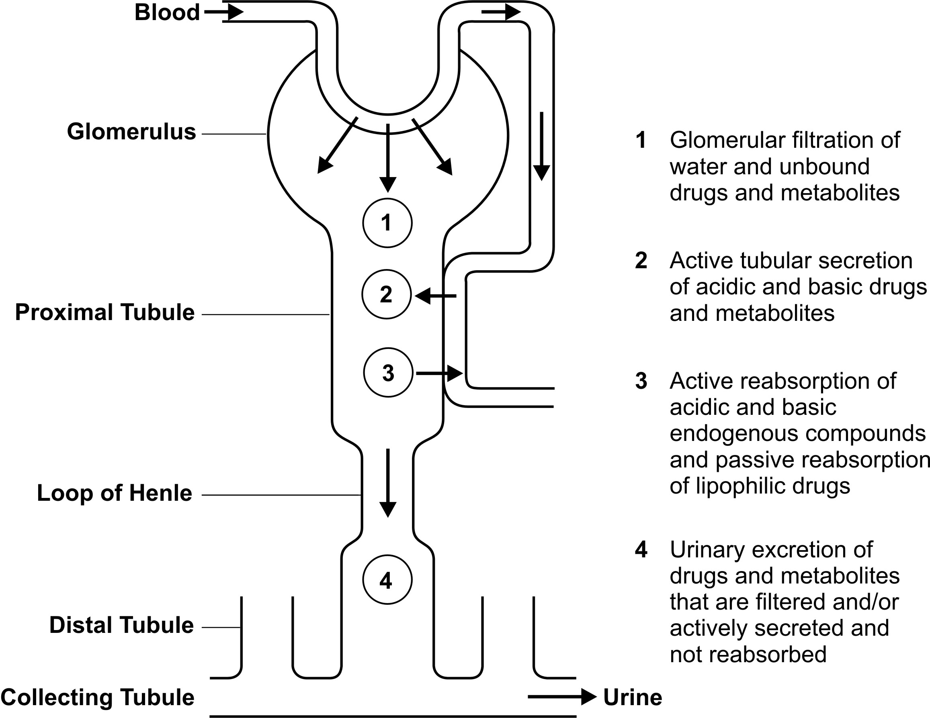
Fig. 6.1 A simplified diagram illustrating processes involved in the urinary excretion of drugs
Rate of Excretion = Rate of Filtration + Rate of Secretion – Rate of Reabsoprtion | (6.1)

Glomerular Filtration
- Glomerular filtration is a non-selective, unidirectional process whereby most compounds, ionised or unionised, are filtered except those that are bound to plasma proteins or blood cells and thus behave as macromolecules.
- The driving force for filtration through the glomerulus is the hydrostatic pressure of the blood flowing in the capillaries.
- Out of the 25% of cardiac output or 1.2 litres of blood/min that goes to the kidneys via renal artery, only 10% or 120 to 130 ml/min is filtered through the glomeruli, the rate being called as the glomerular filtration rate (GFR).
- The GFR can be determined by an agent that is excreted exclusively by filtration and is neither secreted nor reabsorbed in the tubules. The excretion rate value of such an agent is 120 to 130 ml/min. Creatinine, inulin, mannitol and sodium thiosulphate are used to estimate GFR of which the former two are widely used to estimate renal function.

Active Tubular Secretion
- It is a carrier-mediated process which requires energy for transportation of compounds against the concentration gradient.
- The system is capacity-limited and saturable.
- Two active tubular secretion mechanisms have been identified:
1. System for secretion of organic acids/anions like penicillins, salicylates, glucuronides, sulphates, etc. It is the same system by which endogenous acids such as uric acid are secreted.
2. System for secretion of organic bases/cations like morphine, mecamylamine, hexamethonium and endogenous amines such as catecholamines, choline, histamine, etc.
- Two structurally similar drugs having similar ionic charge and employing the same carrier-mediated process for excretion enter into competition.
- A drug with greater rate of clearance will retard the excretion of the other drug with which it competes.
- An interesting example of this is the anionic agent probenecid. Probenecid inhibits the active tubular secretion of organic acids such as penicillins, PAS, PAH, 17-keto steroids, etc. thus increasing their concentration in plasma by at least two fold.

Tubular Reabsorption
- Tubular reabsorption occurs after the glomerular filtration of drugs. It takes place all along the renal tubule.
- Reabsorption of a drug is indicated when the excretion rate values are less than the GFR of 130 ml/min.
- An agent such as glucose that is completely reabsorbed after filtration has a clearance value of zero.
- Contrary to tubular secretion, reabsorption results in an increase in the half-life of a drug.
Tubular reabsorption can either be an:

- Active tubular reabsorption is commonly seen with high threshold endogenous substances or nutrients that the body needs to conserve such as electrolytes, glucose, vitamins, amino acids, etc. Uric acid is also actively reabsorbed (inhibited by the uricosuric agents). Very few drugs are known to undergo reabsorption actively e.g. oxopurinol.

- Passive tubular reabsorption is common for a large number of exogenous substances including drugs. The driving force for such a process i.e. the concentration gradient is established by the back diffusion or reabsorption of water along with sodium and other inorganic ions.

- Since a majority of drugs are weak electrolytes (weak acids or weak bases), diffusion of such agents through the lipoidal tubular membrane depend upon the degree of ionisation which in turn depends on three factors:
- pH of the urine.
- pKa of the drug.
- Urine flow rate.

Urine pH:
- It is an important factor in the sense that it is not constant like the plasma pH but varies between 4.5 to 7.5, the two extremes. Thus, a large pH gradient may exist between urine and plasma.
- The pH of the urine is dependent upon diet, drug intake and pathophysiology of the patient. Food rich in carbohydrates result in higher urinary pH whereas proteins lower it.
- Drugs such as acetazolamide and antacids such as sodium bicarbonate produce alkaline urine while ascorbic acid makes it acidic. More significant alteration in urine pH is brought about by i.v. infusion of solutions of sodium bicarbonate and ammonium chloride which are used in the treatment of acid-base imbalance. Respiratory and metabolic acidosis and alkalosis result in acidification and alkalinisation of the urine respectively.
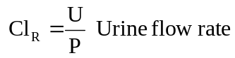
Drug pKa:
- The significance of pH dependent excretion for any particular compound is greatly dependent upon its pKa and lipid solubility.
- A characteristic of drugs, pKa values govern the degree of ionisation at a particular pH.
- A polar and ionised drug will be poorly reabsorbed passively and excreted rapidly.
- Reabsorption is also affected by the lipid solubility of drug; an ionised but lipophilic drug will be reabsorbed while an unionised but polar one will be excreted.
The combined effect of urine pH and drug pKa and lipid solubility on reabsorption of drugs is summarized as follows:
- An acidic drug such as penicillin or a basic drug such as gentamicin which is polar in its unionised form, is not reabsorbed passively, irrespective of the extent of ionisation in urine. Excretion of such drugs is independent of pH of urine and its flow rate. Their rate of excretion is the sum of rate of filtration and rate of active secretion.
- Very weakly acidic, nonpolar drugs (pKa > 8.0) such as phenytoin or very weakly basic, nonpolar drugs (pKa < 6.0) such as propoxyphene are mostly unionised throughout the entire range of urine pH and are therefore extensively reabsorbed passively at all values of urine pH. The rate of excretion of such drugs is always low and insensitive to urine pH.
- A strongly acidic drug (pKa < 2.0) such as cromoglycic acid or a strongly basic drug (pKa > 12.0) such as guanethidine, is completely ionised at all values of urine pH and are, therefore, not reabsorbed. Their rate of excretion is always high and insensitive to pH of urine.
- Only for an acidic drug in the pKa range 3.0 to 8.0 (e.g. several NSAIDs) and for a basic drug in the pKa range 6.0 to 12.0 (e.g. morphine analogs, tricyclic antidepressants, etc.) the extent of reabsorption is greatly dependent upon urine pH and varies from negligible to almost complete; for example, the amount of dexamphetamine excreted in the urine varies from 3 to 55% of the administered dose as the urine pH varies from 8.0 to 5.0. Fig. 6.2 illustrates the influence of urine pH on drug excretion.
- The toxicity due to overdosage of drugs whose excretion is sensitive to pH change can be treated by acidification or alkalinisation of the urine with ammonium chloride or sodium bicarbonate respectively.
- Thus, crystalluria caused by precipitation of sulphonamides in the renal tubules and subsequent kidney damage can be overcome by alkalinising the urine. Excretion of basic drugs can be promoted by acidification of urine. The therapeutic activity of the urinary antiseptic hexamine also depends on the urine pH. It is not converted to active form i.e. formaldehyde unless the urine is acidic.

Urine Flow Rate:
- Only those drugs whose reabsorption is pH-sensitive, for example, weak acids and weak bases, show dependence on urine flow rate. For such agents, reabsorption is inversely proportional to the urinary flow.
- These compounds can be divided into two types based on their extent of reabsorption in relation to that of water:
- Drugs which are reabsorbed to an extent equal to or greater than the reabsorption of water e.g. phenobarbital. In such cases, the relationship between renal clearance and urinary excretion is linear.
- Drugs which are reabsorbed to an extent lower than the reabsorption of water e.g. theophylline and many more drugs. In these cases, the relationship between renal clearance and urinary excretion is convex curvilinear.
- Urine flow rate can be increased by forced diuresis. Forced diuresis is the increase in urine flow induced by large fluid intake or administration of mannitol or other diuretics.
- The principle can be used in an intoxicated person to remove excessive drug by promoting its excretion and decreasing the time for reabsorption.
Both urine pH control and forced diuresis can be used to treat toxicity with drug overdose when –
- Urinary excretion is the major route for elimination of drug.
- The drug is extensively reabsorbed passively from the renal tubules.
- The reabsorption is sensitive to urine pH (and urine flow rate).
Apart from the foregoing discussion on the passive reabsorption of drugs, the process is also important in the reabsorption of low threshold substances such as urea, certain phosphates and sulphates, etc.

CONCEPT OF CLEARANCE

- The sum of individual clearances by all eliminating organs is called as total body clearance or total systemic clearance. It is sometimes expressed as a sum of renal clearance and nonrenal clearance.
- Clearance is defined as the hypothetical volume of body fluids containing drug from which the drug is removed or cleared completely in a specific period of time. It is expressed in ml/min and is a constant for any given plasma drug concentration.  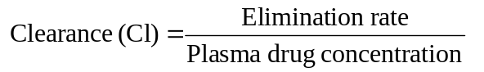 | (6.9)
Renal Clearance (ClR): It can be defined as the volume of blood or plasma which is completely cleared of the unchanged drug by the kidney per unit time. It is expressed mathematically as:
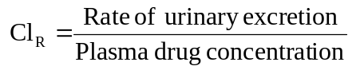 | (6.10)
Physiologically speaking, renal clearance is the ratio of “sum of rate of glomerular filtration and active secretion minus rate of reabsorption” to “plasma drug concentration C”.
(6.11)

Relationship between Renal Clearance Values
and Mechanism of Clearance
Renal Clearance (ml/min) | Renal Clearance Ratio | Mechanism of Renal Clearance | Example(s)
0 (least value) | 0 | Drug filtered and reabsorbed completely | Glucose
< 130 | Above 0, Below 1 | Drug filtered and reabsorbed partially | Lipophilic drugs
130 (GFR) | 1 | Drug is filtered only | Creatinine, Inulin
> 130 | > 1 | Drug filtered as well as secreted actively | Polar, ionic drugs
650 (Highest value) | 5 | Clearance equal to renal plasma flow rate | Iodopyracet, PAH
The contribution of each of the above physiologic processes in clearing a drug cannot be determined by direct measurement. It can however be determined by comparing the clearance values obtained for a drug with that of an agent such as creatinine or inulin which is cleared by glomerular filtration only. The ratio of these two values is called as renal clearance ratio or excretion ratio.
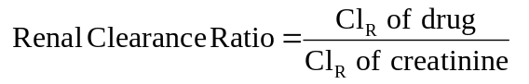 | (6.12)
Thus, depending upon whether the drug is only filtered, filtered and secreted or filtered and reabsorbed, the clearance ratio will vary. The renal clearance values range from zero to 650 ml/min and the clearance ratio from zero to five.

FACTORS AFFECTING RENAL EXCRETION OR RENAL CLEARANCE
1. Physicochemical properties of the drug
2. Plasma concentration of the drug
3. Distribution and binding characteristics of the drug
4. Urine pH
5. Blood flow to the kidneys
6. Biological factors
7. Drug interactions
8. Disease states
Physicochemical Properties of the Drug
Important physicochemical factors affecting renal excretion of a drug are –

Molecular size, pKa and lipid solubility
- The molecular weight of a drug is very critical in its urinary elimination. An agent of small molecular size can be easily filtered through the glomerulus.
- Compounds of weights below 300 Daltons, if water-soluble, are readily excreted by the kidneys. Drugs in the molecular weight range 300 to 500 Daltons can be excreted both in urine and bile.
- Molecules of size greater than 500 Daltons are excreted in urine to a lesser extent
- The influence of drug pKa on excretion has already been discussed. Urinary excretion of an unchanged drug is inversely related to its lipophilicity. This is because, a lipophilic drug is passively reabsorbed to a large extent.
- Stereochemical nature of the drug may also influence renal clearance. If a drug exhibits stereoselective protein binding then the drug enantiomers would exhibit differential filtration rates.
Plasma Concentration of the Drug

- Glomerular filtration and reabsorption are directly affected by plasma drug concentration since both are passive processes.
- A drug that is not bound to plasma proteins and excreted by filtration only, shows a linear relationship between rate of excretion and plasma drug concentration.
- In case of actively reabsorbed drugs, excretion is negligible at low plasma concentrations. Such agents are excreted in urine only when their concentration in the glomerular filtrate exceeds the active reabsorption capacity, e.g. glucose. With drugs that are actively secreted, the rate of excretion increases with increase in plasma concentration up to a saturation level. These situations are depicted in Fig.
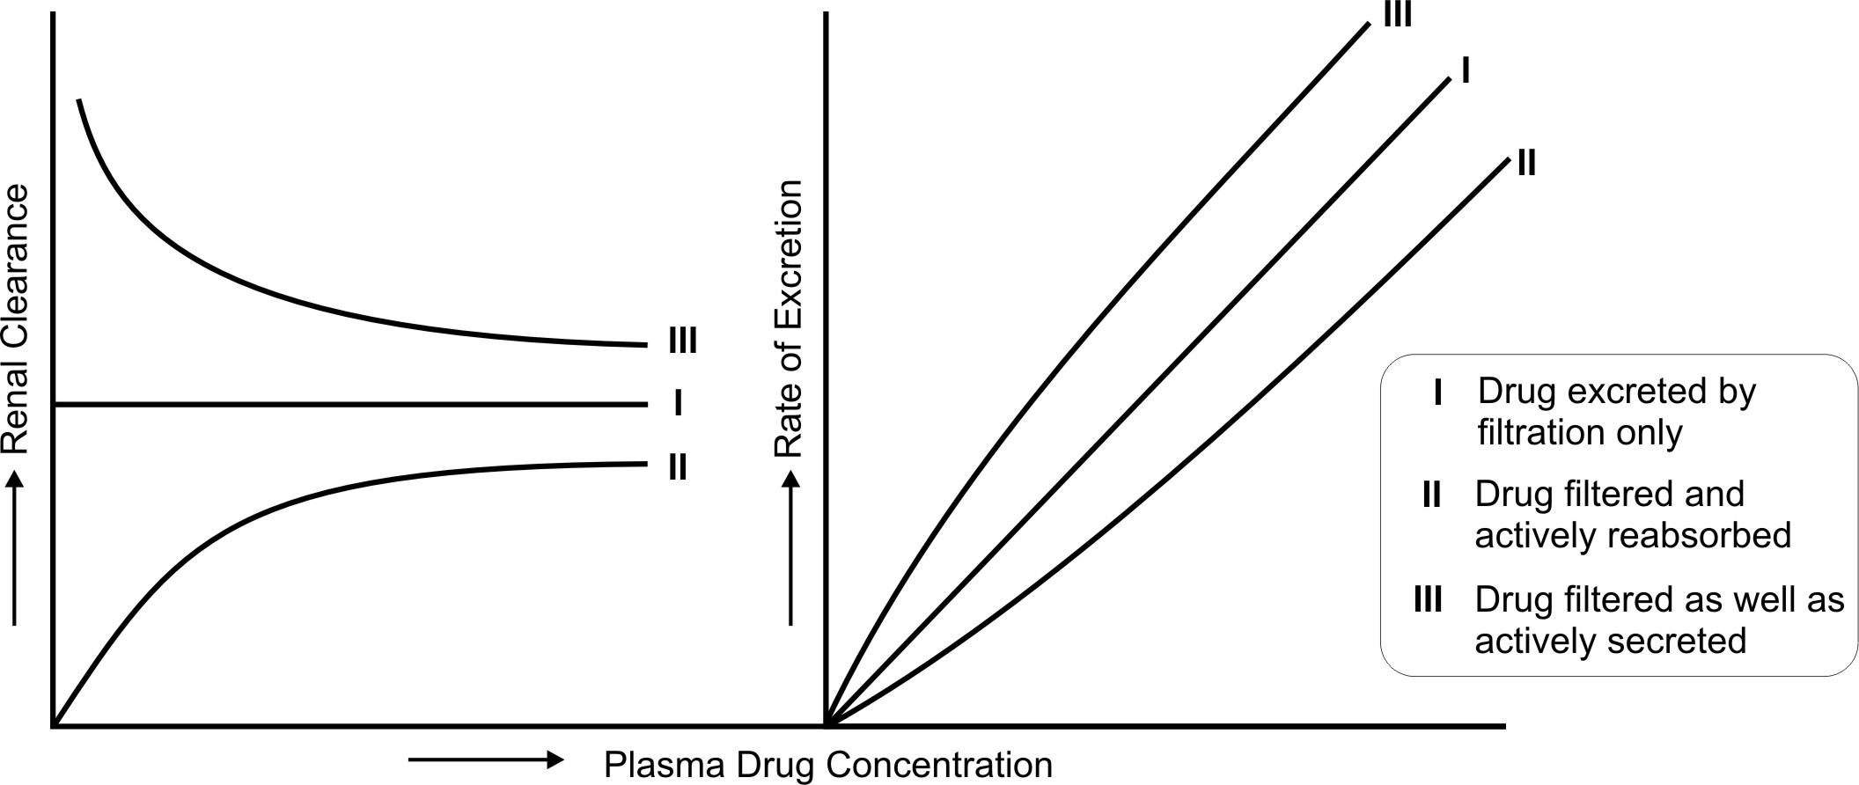
Fig. 6.3. Renal clearance and rate of excretion of a drug in relation to its plasma concentration as affected by the physiologic processes — filtration, active reabsorption and active secretion

Distribution and Binding Characteristics of the Drug
Clearance is inversely related to apparent volume of distribution of drugs. A drug with large Vd is poorly excreted in urine. Drugs restricted to blood compartment have higher excretion rates.
Drugs that are bound to plasma proteins behave as macromolecules and thus cannot be filtered through the glomerulus. Only unbound or free drug appear in the glomerular filtrate. An earlier equation given for renal clearance is:
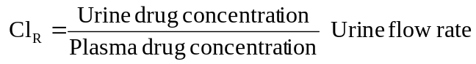 | (6.8)
Since only free drug can be excreted in the urine, the fraction of drug bound to plasma proteins is important and can be computed from equation:
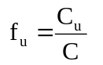 | (6.13)
where, fu = fraction of unbound drug in plasma,
Cu = concentration of unbound drug in plasma, and
C = total plasma concentration of drug.
Thus, equation 6.8 can be written as:
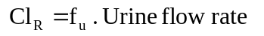 | (6.14)
Drugs extensively bound to proteins have long half-lives because the renal clearance is small and urine flow rate is just 1 to 2 ml/min. The renal clearance of oxytetracycline which is 66% unbound is 99 ml/min while that of doxycycline (7% unbound) is just 16 ml/min.
Actively secreted drugs are much less affected by protein binding, e.g. penicillins. The free fraction of such drugs are filtered as well as secreted actively and dissociation of drug-protein complex occurs rapidly.
The influence of urine pH on renal clearance has already been discussed.
Blood Flow to the Kidneys
The renal blood flow is important in case of drugs excreted by glomerular filtration only and those that are actively secreted. In the latter case, increased perfusion increases the contact of drug with the secretory sites and enhances their elimination. Renal clearance in such instances is said to be perfusion rate-limited.
Biological Factors
Age, sex, species and strain differences, differences in the genetic make-up, circadian rhythm, etc. alter drug excretion. Renal excretion is approximately 10% lower in females than in males. The renal function of newborns is 30 to 40% less in comparison to adults and attains maturity between 2.5 to 5 months of age. In old age, the GFR is reduced and tubular function is altered, the excretion of drugs is thus slowed down and half-life is prolonged.
Drug Interactions
Any drug interaction that results in alteration of protein-drug binding characteristics, renal flood flow, active secretion, urine pH and intrinsic clearance and forced diuresis would alter renal clearance of a drug.
- Alteration in P-D binding: The renal clearance of a drug extensively bound to plasma proteins is increased after displacement with another drug. An interesting example of this is gentamicin induced nephrotoxicity by furosemide. Furosemide does not precipitate this effect by its diuretic effect but by displacing gentamicin from binding sites. The increased free antibiotic concentration accelerates its renal clearance.
- Alteration of Urine pH: Acidification of urine with ammonium chloride, methionine or ascorbic acid enhances excretion of basic drugs. Alkalinisation of urine with citrates, tartarates, bicarbonates and carbonic anhydrase inhibitors promote excretion of acidic drugs.
- Competition for Active Secretion: Phenylbutazone competes with hydroxyhexamide, the active metabolite of antidiabetic agent acetohexamide, for active secretion and thus prolongs its action.
Probenicid is a competitive inhibitor of organic anion transport system.
Cimetidine is competitive inhibitor of organic cation transport system.
- Forced Diuresis: All diuretics increase elimination of drugs whose renal clearance gets affected by urine flow rate.
Disease States—Renal Impairment
Renal dysfunction greatly impairs the elimination of drugs especially those that are primarily excreted by the kidneys. Some of the causes of renal failure are hypertension, diabetes mellitus, hypovolemia (decreased blood supply to the kidneys), pyelonephritis (inflammation of kidney due to infections, etc.), nephroallergens (e.g. nephrotoxic serum) and nephrotoxic agents such as aminoglycosides, phenacetin and heavy metals such as lead and mercury.
Uraemia, characterized by impaired glomerular filtration and accumulation of fluids and protein metabolites, also impairs renal clearance of drugs. In both these conditions, the half-lives of drugs are increased. As a consequence, drug accumulation and toxicity may result. Determination of renal function is therefore important in such conditions in order to monitor the dosage regimen.

RENAL FUNCTION AND RENAL FAILURE
Renal function can be determined by measuring the GFR. Both endogenous and exogenous substances have been used as markers to measure GFR. In order to be useful as a marker, the agent should entirely get excreted in unchanged form by glomerular filtration only and should be physiologically and pharmacologically inert.
Inulin (the exogenous fructose polysaccharide) and serum creatinine level have been used successfully for such purposes.
Inulin clearance provides an accurate measure of GFR but has the disadvantage of being a tedious method. Clinically, creatinine clearance is widely used to assess renal function.
Creatinine is an endogenous amine produced as a result of muscle catabolism. It is excreted unchanged in the urine by glomerular filtration only. An advantage of this test is that it can be correlated to the steady-state concentration of creatinine in plasma and needs no collection of urine. The method involves determination of serum creatinine levels. Since creatinine production varies with age, weight and gender, different formulae are used to calculate creatinine clearance from the serum creatinine values.
For Children (between 1 to 20 years),
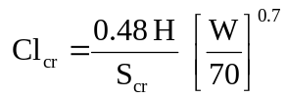 | (6.15)
For Adults (above 20 years),
Males, 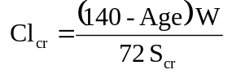 | (6.16)
Females, 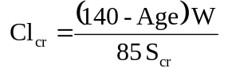 | (6.17)
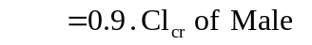
where, Clcr = creatinine clearance in ml/min,
Scr = serum creatinine in mg%,
H = height in cms, and
W = weight in Kg.
Age is measured in years.
A direct method for determining creatinine clearance is determination of the amount of creatinine excreted in urine in 24 hours (to calculate the rate of creatinine excretion) and the mean of serum creatinine from blood samples taken just before and immediately after the urine collection period. Following formula is used:
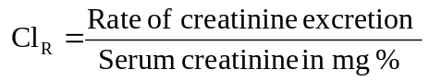 | (6.18)
The normal creatinine clearance value is 120 to 130 ml/min. A value of 20 to 50 ml/min denotes moderate renal failure and values below 10 ml/min indicate severe renal impairment.
The renal function, RF is calculated by equation 6.19.
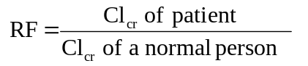 | (6.19)
Dose Adjustment in Renal Failure
Dosage regimen need not be changed when
  - The fraction of drug excreted unchanged, fu is ≤ 0.3, and
  - The renal function RF is ≥ 0.7 of normal.

- The above generalization is based on the assumption that the metabolites are inactive and binding characteristics and drug availability are unaltered and so is the renal function in kidney failure conditions.
- When the fu value approaches unity and RF approaches zero, elimination is extremely slowed down and dosing should be reduced drastically. The significance of nonrenal clearance increases in such conditions.
The required dose in patients with renal impairment can be calculated by the simple formula:
(6.20)
The dosing interval in hours can be computed from the following equation:
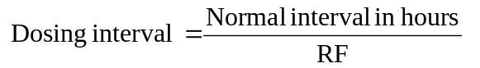 | (6.21)
When the drug is eliminated both by renal and nonrenal mechanisms, the dose to be administered in patients with renal failure is obtained from equation 6.22.
(6.22)
Dialysis and Haemoperfusion

Dialysis is a process in which easily diffusible substances are separated from poorly diffusible ones by the use of semipermeable membrane.
There are two procedures for dialysis:
1. Peritoneal dialysis, and
2. Haemodialysis.

- In the former, the semipermeable membrane is the natural membrane of the peritoneal cavity.
- The method involves introduction of the dialysate fluid into the abdomen by inserting the catheter and draining and discarding the same after a certain period of time. In haemodialysis, the semipermeable membrane is an artificial membrane.
- Since the system is outside the body, it is also called as extracorporeal dialysis. The equipment is referred to as artificial kidney or haemodialyser.
- Apart from the removal of toxic waste from the body, haemodialysis is also useful in the treatment of overdose or poisoning situations where rapid removal of drug becomes necessary to save the life of the patient. Patients of kidney failure require dialysis of blood every 2 days. Each treatment period lasts for 3 to 4 hours.
Factors that govern the removal of substances by haemodialysis are:
Water Solubility: Only water-soluble substances are dialyzed; lipid soluble drugs such as glutethimide cannot be removed by dialysis.
Molecular Weight: Molecules with size less than 500 Daltons are dialyzed easily, e.g. many unbound drugs; drugs having large molecular weight such as vancomycin cannot be dialyzed.
Protein Binding: Drugs bound to plasma proteins or blood cells cannot be dialyzed since dialysis is a passive diffusion process.
Volume of Distribution: Drugs with large volume of distribution are extensively distributed throughout the body and therefore less easily removed by dialysis, e.g. digoxin.

- The dialyzing fluid contains sodium, potassium, calcium, chloride and acetate ions, and dextrose and other constituents in the same concentration as that in plasma.
- The unwanted metabolites in the patient’s blood such as urea, uric acid, creatinine, etc. diffuse into the dialysate until equilibrium.
- Since the volume of dialysate is much greater than that of blood and since it is replenished with fresh fluid from time to time, almost complete removal of unwanted substances from the blood is possible.
- Drugs which can be removed by haemodialysis are barbiturates, aminoglycosides, chloral hydrate, lithium, etc.

The term dialysance, also called as dialysis clearance, is used to express the ability of machine to clear the drug from blood. It is defined in a manner similar to clearance by equation:
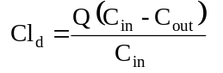 | (6.23)
where, Cld = dialysance or dialysis clearance
Q = blood flow rate to dialyser
Cin = concentration of drug in blood entering the dialyser
Cout = concentration of drug in blood leaving the dialyser

In haemoperfusion, the blood is passed through a bed of adsorbent such as charcoal or resin; as a result, drugs and other unwanted molecules are adsorbed while plasma proteins are not. The method is also useful in treating severe drug intoxication. The limitation of haemoperfusion is that it also removes the blood platelets, white cells and endogenous steroids.

NON-RENAL ROUTES OF DRUG EXCRETION
Drugs and their metabolites may also be excreted by routes other than the renal route, called as the extrarenal or nonrenal routes of drug excretion. The various such excretion processes are:
1. Biliary excretion
2. Pulmonary excretion
3. Salivary excretion
4. Mammary excretion
5. Skin/dermal excretion
6. Gastrointestinal excretion
7. Genital excretion
Biliary Excretion of Drugs—Enterohepatic Cycling
The hepatic cells lining the bile canaliculi produce bile. The production and secretion of bile are active processes. The bile secreted from liver, after storage in the gall bladder, is secreted in the duodenum. In humans, the bile flow rate is a steady 0.5 to 1 ml/min. Bile is important in the digestion and absorption of fats. Almost 90% of the secreted bile acids are reabsorbed from the intestine and transported back to the liver for re-secretion. The rest is excreted in faeces.
Being an active process, bile secretion is capacity-limited and subject to saturation. The process is exactly analogous to active renal secretion. Different transport mechanisms exist for the secretion of organic anions, cations and neutral polar compounds. A drug, whose biliary concentration is less than that in plasma, has a small biliary clearance and vice versa. In some instances, the bile to plasma concentration ratio of drug can approach 1000 in which cases, the biliary clearance can be as high as 500 ml/min or more.
Compounds that are excreted in bile have been classified into 3 categories on the basis of their bile/plasma concentration ratios:
Group A compounds whose ratio is approximately 1, e.g. sodium, potassium and chloride ions and glucose.
Group B compounds whose ratio is >1, usually from 10 to 1000, e.g. bile salts, bilirubin glucuronide, creatinine, sulphobromophthalein conjugates, etc.
Group C compounds with ratio < 1, e.g. sucrose, inulin, phosphates, phospholipids and mucoproteins.
Drugs can fall in any of the above three categories.
Several factors influence secretion of drugs in bile –
1. Physicochemical Properties of the Drug
The most important factor governing the excretion of drugs in bile is their molecular weight. Its influence on biliary excretion is summarized in the Table 6.3.
Polarity is the other physicochemical property of drug influencing biliary excretion. Greater the polarity, better the excretion. Thus, metabolites are more excreted in bile than the parent drugs because of their increased polarity. The molecular weight threshold for biliary excretion of drugs is also dependent upon its polarity. A threshold of 300 Daltons and greater than 300 Daltons is necessary for organic cations (e.g. quaternaries) and organic anions respectively. Nonionic compounds should also be highly polar for biliary excretion, e.g. cardiac glycosides.

2. Nature of Biotransformation Process
A metabolic reaction that greatly increases the polarity as well as the molecular weight of drug favours biliary excretion of the metabolite. Thus, phase II reactions, mainly glucuronidation and conjugation with glutathione, result in metabolites with increased tendency for biliary excretion (increase the molecular weight by 176 and 300 Daltons respectively). Examples of drugs excreted in the bile as glucuronides are morphine, chloramphenicol and indomethacin. Stilbestrol glucuronide is almost entirely excreted in bile. Glutathione conjugates are exclusively excreted via bile and are not observable in the urine because of their large molecular size. Conjugation with amino acids and acetylation and methylation reactions do not result in metabolites with greatly increased molecular weight and therefore have little influence on biliary excretion of xenobiotics. For a drug to be excreted unchanged in the bile, it must have a highly polar functional group such as -COOH (cromoglycic acid), -SO3H (amaranth), -NH4+ (oxyphenonium), etc. Clomiphene citrate, an ovulation inducer, is almost completely removed from the body via biliary excretion.
3. Other Factors
- Miscellaneous factors influencing biliary excretion of drugs include sex and species differences, protein-drug binding, disease states, drug interactions, etc.
- Protein bound drugs can also be excreted in the bile since the secretion is an active process.
- In cholestasis, the bile flow rate is reduced thereby decreasing biliary excretion of drugs. Agents such as phenobarbital stimulate biliary excretion of drugs, firstly, by enhancing the rate of glucuronidation, and secondly, by promoting bile flow.
- The route of drug administration also influences biliary drug excretion. Orally administered drugs which during absorption process go to the liver, are excreted more in bile in comparison to parenterally administered drugs.
- Food also has a direct influence on biliary excretion of drugs. Protein and fat rich food increase bile flow.
The efficacy of drug excretion by the biliary system and hepatic function can be tested by an agent that is exclusively and completely eliminated unchanged in the bile, e.g. sulphobromophthalein. This marker is excreted within half an hour in the intestine when the hepatic function is normal. A delay in its excretion is indicative of hepatic and biliary malfunction. The marker is also useful in determining hepatic blood flow rate.
The ability of liver to excrete the drug in the bile is expressed by biliary clearance (equation 6.24).
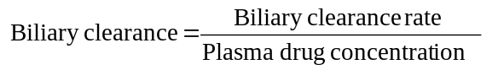 | (6.24a)
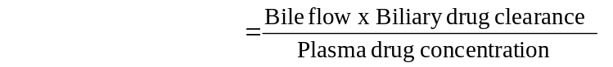 | (6.24b)
This phenomenon of drug cycling between the intestine and the liver is called as enterohepatic cycling or enterohepatic circulation of drugs (Fig. 6.5.).
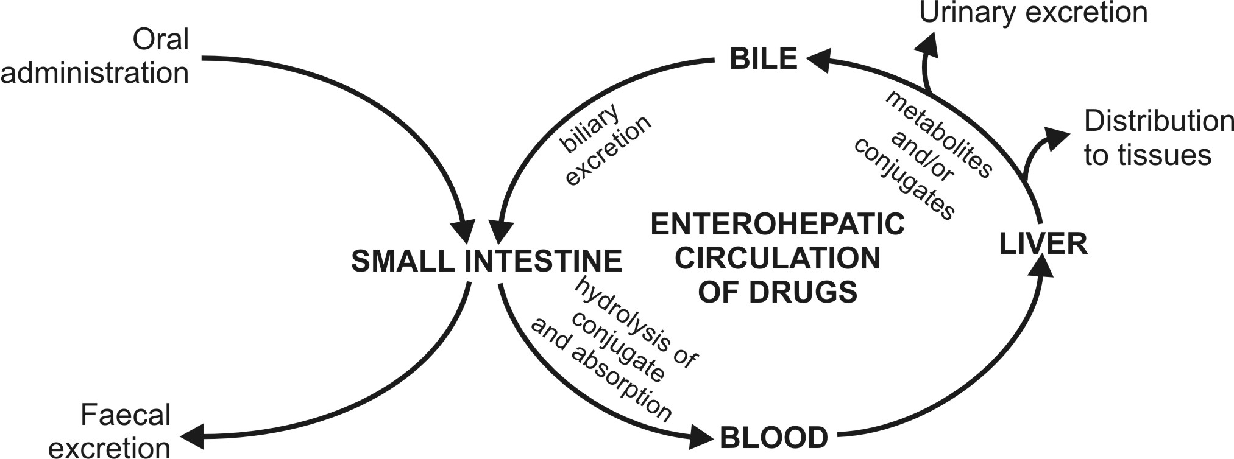
Fig. 6.5. Enterohepatic cycling of drugs
Such a recycling process continues until the drug is biotransformed in the liver or is excreted in the urine or both. The drugs which are secreted via bile in the intestine but not reabsorbed, are finally excreted in the faeces.

- Enterohepatic circulation is important in the conservation of important endogenous substances such as vitamin B12, vitamin D3, folic acid, several steroid hormones and bile salts.
- The process results in prolongation of half-lives of several drugs (e.g. carbenoxolone) which are extensively excreted in bile.
- The half-life of agents such as DDT, which are resistant to biotransformation and are highly lipophilic, may increase to several days due to such a recycling phenomenon. The prolonged therapeutic activity of oral contraceptives (upto 12 hours) is also due to such a recirculation.
- Other examples of drugs undergoing enterohepatic circulation are cardiac glycosides, rifampicin, chlorpromazine and indomethacin.
- Drug interactions affecting enterohepatic cycling occur when agents such as antibiotics kill the intestinal microflora and thus retard hydrolysis of drug conjugates and their subsequent reabsorption, or the unabsorbable ion exchange resins such as cholestyramine which bind strongly to the acidic and neutral drugs (e.g. digitoxin) and thus prevent their reabsorption.
- The principle of adsorption onto the resins in the GIT can however be used to treat pesticide poisoning by promoting their faecal excretion.
- Biliary excretion of drugs can be assessed by giving the drugs parenterally and detecting their presence in faeces. This also rules out the doubt about the incomplete absorption of such drugs when given orally and observed in faeces.
Pulmonary Excretion
Gaseous and volatile substances such as the general anaesthetics (e.g. halothane) are absorbed through the lungs by simple diffusion. Similarly, their excretion by diffusion into the expired air is possible. Factors influencing pulmonary excretion of a drug include pulmonary blood flow, rate of respiration, solubility of the volatile substance, etc. Gaseous anaesthetics such as nitrous oxide which are not very soluble in blood are excreted rapidly. Generally intact gaseous drugs are excreted but metabolites are not. Compounds like alcohol which have high solubility in blood and tissues are excreted slowly by the lungs. The principle involved in the pulmonary excretion of benzene and halobenzenes is analogous to that of steam distillation.
Salivary Excretion
Excretion of drugs in saliva is also a passive diffusion process and therefore predictable on the basis of pH-partition hypothesis. The pH of saliva varies from 5.8 to 8.4. The mean salivary pH in man is 6.4. Unionised, lipid soluble drugs at this pH are excreted passively in the saliva. Equations analogous to 6.3, 6.5, 6.6 and 6.7 can be written for drugs with known pKa at the salivary pH and percent ionisation and saliva/plasma drug concentration ratio (S/P) can be computed.
for weak acids,
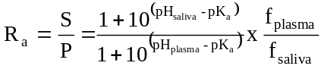 | (6.25)
for weak bases,
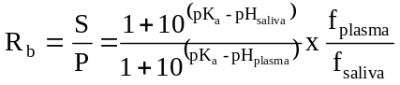 | (6.26)
where, fplasma and fsaliva are free drug fractions in plasma and in saliva respectively.
The S/P ratios have been found to be less than 1 for weak acids and greater than 1 for weak bases i.e. basic drugs are excreted more in saliva as compared to acidic drugs. The salivary concentration of some drugs reaches as high as 0.1%. Since the S/P ratio is fairly constant for several drugs, their blood concentration can be determined by detecting the amount of drug excreted in saliva, e.g. caffeine, theophylline, phenytoin, carbamazepine, etc. Some drugs are actively secreted in saliva, e.g. lithium, the concentration of which is sometimes 2 to 3 times that in plasma. Penicillin and phenytoin are also actively secreted in saliva.
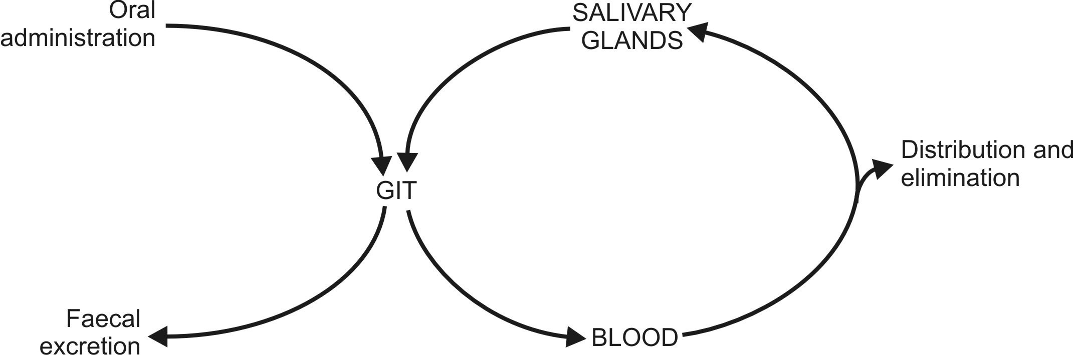
Fig. 6.6. Salivary cycling of drugs
The bitter after taste in the mouth of a patient on medication is an indication of drug excretion in saliva. In few instances, the process is responsible for side effects such as black hairy tongue in patients receiving antibiotics, gingival hyperplasia due to phenytoin, etc. Some basic drugs inhibit saliva secretion and are responsible for dryness of mouth.
Drugs excreted in saliva can undergo cycling in a fashion similar to enterohepatic cycling, e.g. sulphonamides, antibiotics, clonidine, etc. (Fig. 6.6.).
Mammary Excretion
Excretion of a drug in milk is important since it can gain entry into the breast-feeding infant.
Milk consists of lactic secretions originating from the extracellular fluid and is rich in fats and proteins. About 0.5 to 1 litre/day of milk is secreted in lactating mothers
Excretion of drugs in milk is a passive process and is dependent upon pH-partition behaviour, molecular weight, lipid solubility and degree of ionisation. The pH of milk varies from 6.4 to 7.6 with a mean pH of 7.0.

But some potent drugs such as barbiturates, morphine and ergotamine may induce toxicity in infants. Some examples of toxicity to breast-fed infants owing to excretion of drug in milk are –

- Chloramphenicol: Possible bone marrow suppression.
- Diazepam: Accumulation and sedation.
- Heroin: Prolonged neonatal dependence.
- Methadone: Possible withdrawal syndrome if breast-feeding is stopped suddenly.
- Propylthiouracil: Suppression of thyroid function.
- Tetracycline: Permanent staining of infant teeth.

Wherever possible, nursing mothers should avoid drugs.
If medication is unavoidable, the infant should be bottle-fed.

Skin Excretion
Drugs excreted through the skin via sweat also follow pH-partition hypothesis. Passive excretion of drugs and their metabolites through skin is responsible to some extent for the urticaria and dermatitis and other hypersensitivity reactions. Compounds such as benzoic acid, salicylic acid, alcohol and antipyrine and heavy metals like lead, mercury and arsenic are excreted in sweat.
Gastrointestinal Excretion
Excretion of drugs into the GIT usually occurs after parenteral administration when the concentration gradient for passive diffusion is favourable. The process is reverse of GI absorption of drugs. Water soluble and ionised form of weakly acidic and basic drugs is excreted in the GIT, e.g. nicotine and quinine are excreted in stomach. Orally administered drugs can also be absorbed and excreted in the GIT. Drugs excreted in the GIT are reabsorbed into the systemic circulation and undergo recycling.
Genital Excretion
Reproductive tract and genital secretions may contain the excreted drugs. Some drugs have been detected in semen.

Drugs can also get excreted via the lachrymal fluid.

A summary of drugs excreted by various routes

Excretion Pathways, Transport Mechanisms and Drugs Excreted
Excretory Route | Mechanism | Drugs Excreted
Urine | Glomerular filtration, active secretion, active/passive reabsorption | Free, hydrophilic, unchanged drugs/metabolites/conjugates of MW < 500
Bile | Active secretion | Hydrophilic, unchanged drugs/metabolites/conjugates of MW ≥ 500
Lung | Passive diffusion | Gaseous and volatile, blood and tissue insoluble drugs
Saliva | Passive diffusion, active transport | Free, unionised, lipophilic drugs, some polar drugs
Milk | Passive diffusion | Free, unionised, lipophilic drugs (generally basic)
Sweat | Passive diffusion | Free, unionised, lipophilic drugs
Intestine | Passive diffusion | Water-soluble, ionised drugs

